**Create your own body parts cube - Colour, cut and glue!!**

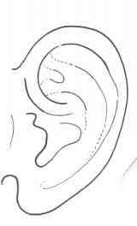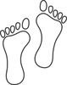

**Feet**

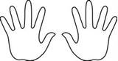

**Hands**



**Nose**

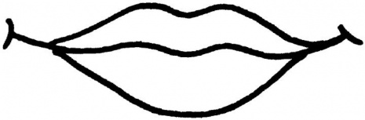

**Mouth**

**Ear**

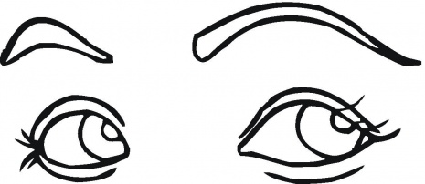

**Eyes**

